**SCREENSHOT FILE  
Course-end Project 1**

**Set Up and Monitor a WordPress Instance**

**Steps to be followed to implement the project:**

**  
**Step 2: Create AMI from list wordpress instance  
**

**Step 3: Launch a new wordpress instance (9AM-6PM) using AMI of first instance**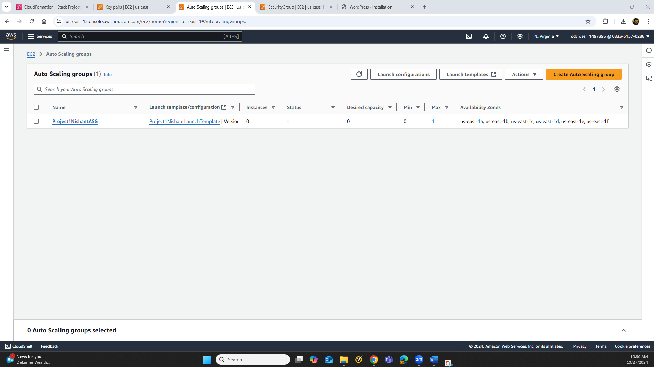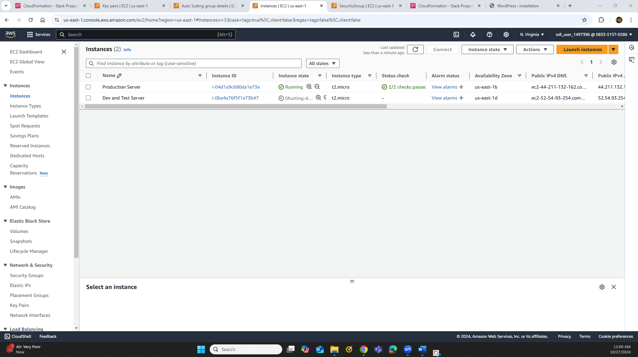

**Step 4: Check availability monitoring of wordpress instance using Route53  
**